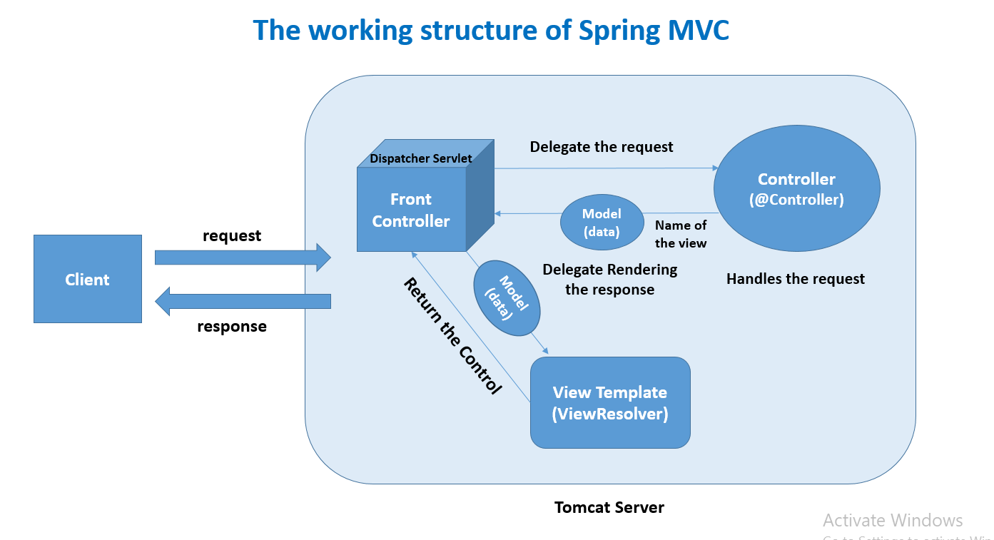

**Application Interface**

Home page:

* Showing all the records on the home page
* Records can be edited in the **Action** column which will delegate the URL to “**update-product”**
* Records can be deleted in the **Action** column which will delegate the URL to **“/”** i.e. index.
* **Add Product** button will delegate the request to add a new product page where we have a form.

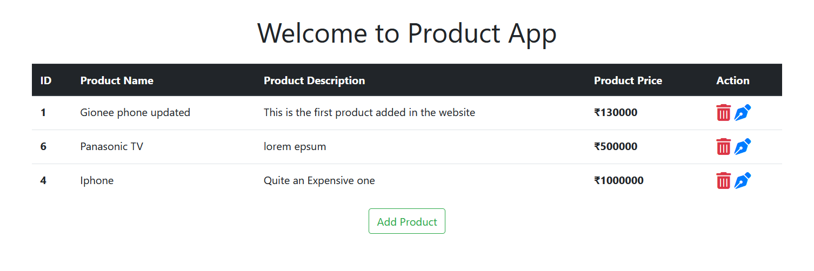

**Add Product Page**

* After adding the product from this page the records will be inserted into the **database** via **Hibernate**
* **Back button** will simply delegate the URL to the home page i.e. **“/’**

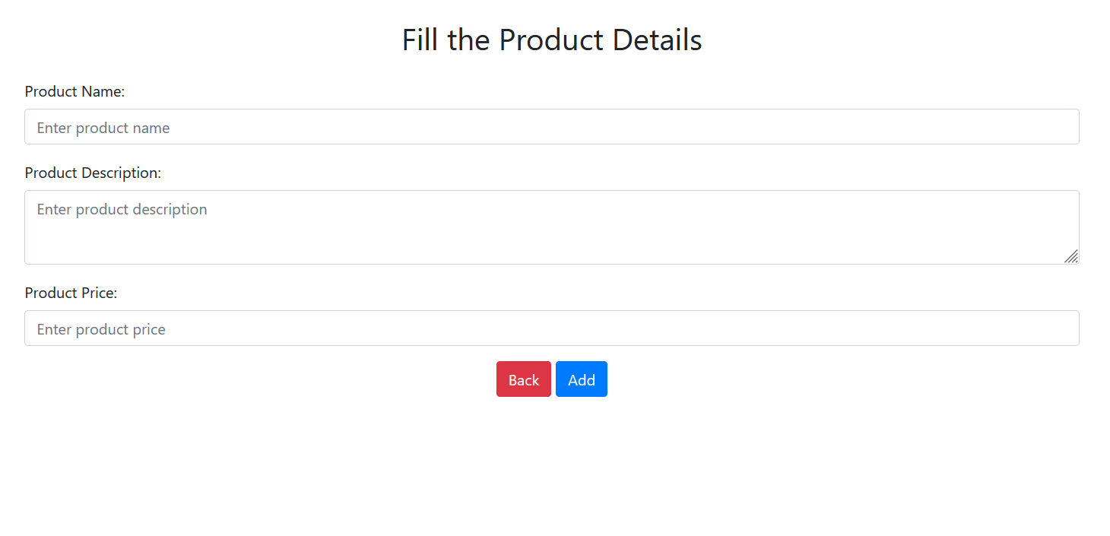

**Update Product**

* We can update products on this page on the specific **Id** that we have selected.
* **Back button** will simply delegate the URL to the home page i.e. **“/’**

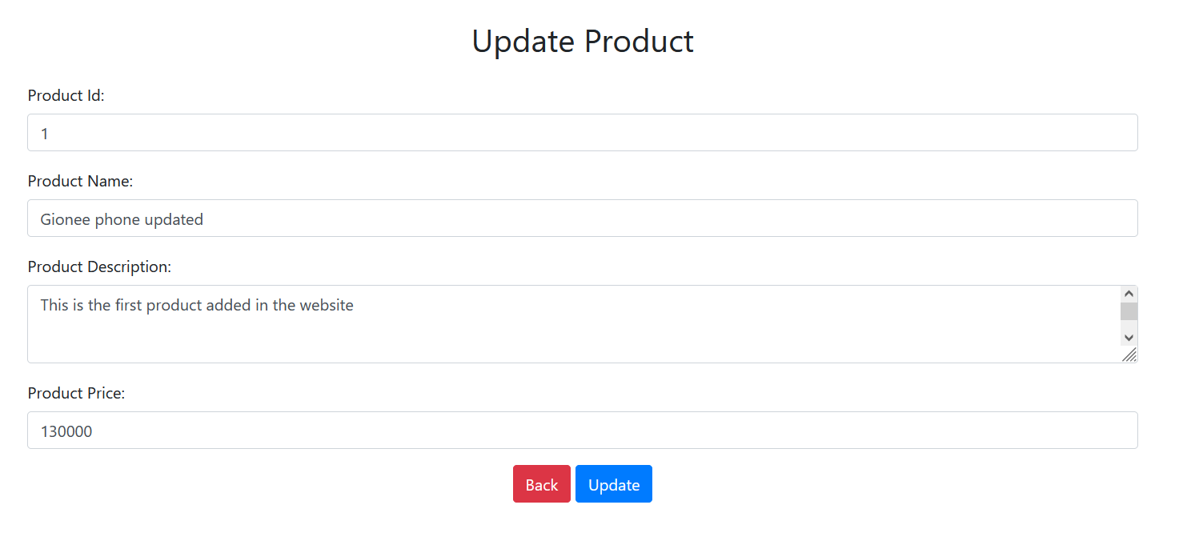

**Delete product**

* The product will be deleted based on the ID we have selected when we click on the **trash** icon

